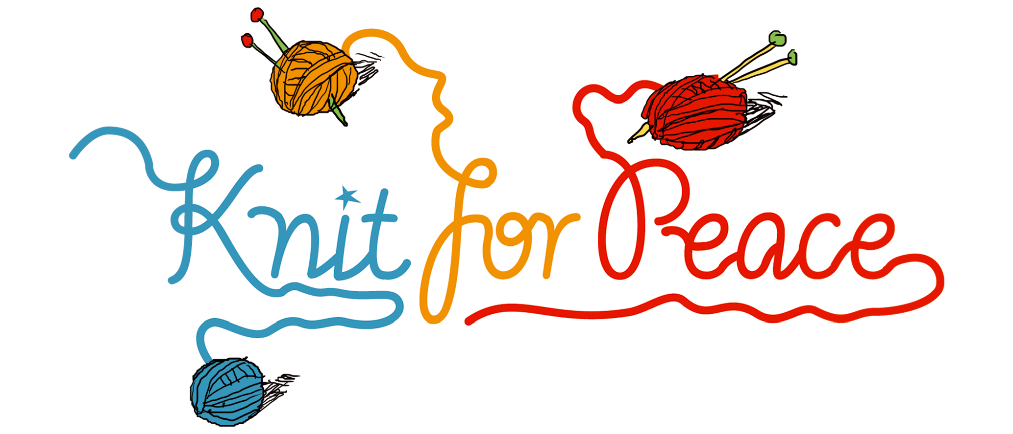

Simple jumpers for babies and toddlers
Designed by Knit for Peace

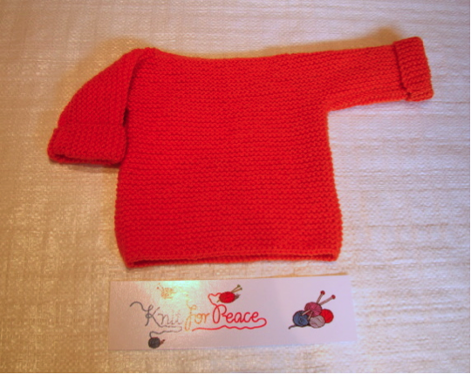

Size: new born; 3-6 months

Yarn: 100g; 150g

For all sizes: 4mm needles and a sewing needle for making up the jumpers.

Tension: 21 stitches and 44 rows over garter stich (knit each row) using 4mm needles will make a 10cm x 10cm square.

Abbreviations: beg - beginning; k - knit; sts - stitches

Method:

This jumper is knitted all in one piece.

Cast on 44 (52) sts loosely with 4mm needles.
Knit 60 (80) rows.
Cast on 30 (44) sts loosely at the beg of the next 2 rows, forming the sleeves.
K a further 30 (48) rows on these 104 (140) sts.
Next row: K36 (43) sts, cast off 32 (54) sts loosely for the neck, k 35 (42).
Next row: K36 (43) sts, cast on 32 (54) sts loosely for the neck, k 36 (43).

K (30) 48 rows.
Cast off 30 (44) sts loosely at the beginning of the next 2 rows.
K 60 (80) rows on these 44 (52) sts.
Cast off loosely.

To make up, sew any ends in and then sew the side and sleeve seams on each side.

Please send your completed items to:
Knit for Peace, Radius Works, Back Lane, London NW3 1HL.

Knit for Peace would be happy to receive any donations.
Please see the website at www.knitforpeace.org.uk for details.

Thank you!

